Software Requirements Specification

for

The Tabeisa start-up café
Version 1.0 approved
Prepared by Tyronne Lloyd Hendricks
Sim Office
22/09/2021
Table of Contents
1. Introduction 1
1.1 Purpose 1
1.2 Document Conventions 1
1.3 Intended Audience and Reading Suggestions 1
1.4 Product Scope 1
1.5 References 2
2. Overall Description 2
2.1 Product Perspective 2
2.2 Product Functions 3
2.3 User Classes and Characteristics 4
2.4 Operating Environment 4
2.5 Design and Implementation Constraints 4
2.6 User Documentation 5
2.7 Assumptions and Dependencies 5
3. External Interface Requirements 6
3.1 User Interfaces 6
3.2 Hardware Interfaces 7
3.3 Software Interfaces 8
3.4 Communications Interfaces 8
4. System Features 9
4.1 Email: 9
4.2 FAQ Bot: 9
4.3 News Portal: 10
4.4 Business Portal: 11
5. Other Nonfunctional Requirements 12
5.1 Performance Requirements 12
5.2 Safety Requirements 13
5.3 Security Requirements 13
5.4 Software Quality Attributes 14
5.5 Business Rules 14

Revision History
Name | Date | Reason For Changes | Version

Introduction

Purpose
Context: The Tabeisa start-up café was a physical shop that provided services of a general café but with added twist of offering entrepreneurial and mentorship opportunities.

The purpose of the document is to build a fully functional website that serves as an online platform that provides the customer with all the services the physical Tabeisa start-up café had but online.

Document Conventions
DB | Database
CPUT | Cape Peninsula University of Technology
TABEISA | Technical and Business Education Initiative in South Africa

Intended Audience and Reading Suggestions
This project is a website creation for the Tabeisa start-up café, and it is restricted within the use of the university. This has been created through the guidance of one of the lecturers (Prima Inderlal) at CPUT.This project is useful for online purchasing and viewing of services provided by the business

Product Scope
The product scope would be to rebrand the Tabeisa Start-up Cafe department by creating a website which would consist of a list containing the virtual service offerings, a portal for various companies to register and a chat bot function which would answer the frequently asked questions

The objectives are:
- Creating a website with various pages
- Adding products to cart functionality
- Selecting mentorship program functionality
- Hosting website (CTS)
- Creating a chat bot functionality

References
Journal used as reference:
BANDAKKANAVAR, R.
Software Requirements Specification document with example - Krazytech
In-text: (Bandakkanavar, 2021)
Your Bibliography: Bandakkanavar, R., 2021. Software Requirements Specification document with example - Krazytech. [online] Krazytech. Available at: <https://krazytech.com/projects/sample-software-requirements-specificationsrs-report-airline-database> [Accessed 22 September 2021].

Cputacza.sharepoint.com. 2021. Sign in to your account. [online] Available at:
https://cputacza.sharepoint.com/sites/SIMOffice/Shared%20Documents/General/SIM%20Office%20Administration/SynDev/PMO%20folder/Project%20Initiate [Accessed 22 September 2021].

Overall Description

Product Perspective
The purpose of this project is rebranding the Tabeisa (Technical and Business Education Initiative in South Africa) Start-up Cafe Department. The aim of the Tabeisa Start-up Café was to help the CPUT (Cape Peninsula University of Technology) community, and the public empower themselves through the free acquisition of entrepreneurial skills and mentorship. The Start Up Café offers a forum for prospective clients to register with Tabeisa, qualifying them for guidance on the training required to manage a project or business at any stage of its life cycle. Appropriate training is given at the Start Up Café or through one of their many partners. Registered clients also receive assistance with tendering patent registration, company registration, applying for finance, and export networking with local and international businesses. Tabeisa assists with strategies to encourage black economic empowerment by helping entrepreneurs from disadvantaged communities set up small businesses and understand what entrepreneurship is. Tabeisa has been closed for many years and will reopen again this year. This project requires a complete rebranding of Tabeisa and the services offered. Tabeisa also offered a start-up café in its virtual form, accessible at www. tabeisa startupcafe.co.za. This website no longer exists. A new website would need to be developed. Whereby the system must have a POPIA statement for using the website. The proof of consenting must be automated. The clients registered with Tabeisa. Registered clients qualify for guidance on the training required to manage a project or business at any stage of its life cycle.
Registered clients also receive assistance:
- patent registration
- Company registration
- Applying for finance
- Expert networking with local and international businesses.

Product Functions
The major functions the user will perform are:
- A user must be able to login to the system
- System must be able to send an approval request after the user enters personal information
- System must be able to show invalid request when user put incorrect login credentials
- A user must be able to view all services
- System to be able to send a confirmation when user has made the selection
- User must be able to save the changes made and
- be able to close/exit the system

Data Flow Diagram
User

service
confirmation

Invalid service
request request

Register User
Confirm Login
Check Request

valid
request

user_id service_id

Users Services Service registration

User Classes and Characteristics
<Identify the various user classes that you anticipate will use this product. User classes may be differentiated based on frequency of use, subset of product functions used, technical expertise, security or privilege levels, educational level, or experience. Describe the pertinent characteristics of each user class. Certain requirements may pertain only to certain user classes. Distinguish the most important user classes for this product from those who are less important to satisfy.>

Operating Environment
The software environment is where the technical development and testing of an application or website takes place. These software environments can be divided into three main categories, each with their own unique purpose and functionalities. In this case, we are going to use the development environment, where most of the technical programming takes place. Each browser is slightly different and displays web pages in diverse ways, to handle the diverse ways that browsers interact with different web languages, such as HTML, XML, and PHP, it must be specialized. The development environments are set up on local PC’s and are facilitated by a Git repository.

Design and Implementation Constraints
Designing the website is part of the constraints, knowing where we should start needs creativity and imagination. We value our design constraints at this initial stage because they might create obstruction to our project success.

-Development schedule which includes design detailing and compliance tests.

-Functional requirements, such as feature specs for a website.

-Meeting clearly the client's usability principles.

-The end-user is the main focus while designing the website, more interaction with the client is needed in order to design enjoyable website for the audience, not for us.

-As we are rebranding, the clients existing business model and brand add to the constraints as the give us direction of the visual view of the website we are designing.

User Documentation

Website User Manual
Introduction to the Tabeisa Start up Cafe Website

This manual explains the many ways in which to use the site in order to get the most out of our vast resource.

Login:
- How to register
- How to Login

Viewing Programs:
- List of different Programs

Viewing Products:
- List of different types of products & Services

Viewing Solution:
- List of Different Solutions

Viewing Events:
- List of Different Events

About US:
- A reflection of the purpose and personality of Tabeisa start up café and its owners.

Contacts US:
- An email address and a contact form for visitors to fill out.

Searching:
- Free location search tool on the website where users can locate what they looking for.

Assumptions and Dependencies
We assume that the website will be user-friendly, the user will be able to navigate the website without any hustle. The users can only get access to information regarding company registration when they has signed-up on the website.
The user can access the website on any browser by navigating the browser to the address of the TABEISA start-up café website.

We assume that the TABEISA start-up café website will be running on an appropriate working web server and database system with an Internet connection that allows this system to perform all communications with the clients.

The user can only register as a client once on the website.
The client can only use the TABEISA start-up café resources to start-up one company.
The user cannot edit their account profile information without logging in on the website.
Working on the website requires internet connection.

External Interface Requirements

User Interfaces
Define the software components for which a user interface is needed.

Pages of the Website:

- Home Page.
- About Page.
- Contact Page.
- Services Offered Page.
- Events.
- Investments (Donations).

Every Website Page should allow navigation to every other page on the Website Page, this could be achieved through having a static navigation bar on the top of every page which is always accessible.

GUI standards that should be adhered to are the following:

- Adhering to CPUT’s brand guide.
- Consistent design across the entire website.
- Responsiveness, having a seamless experience across all types of digital devices for end users.
- Error prevention, alerting users when they are providing incorrect information (i.e., when providing email information).

The basic parts of the Website should include, but not be limited to:

- Website Logo.
- The Header.
- The Footer.
- Menu Bar.
- Call To Action (CTA).
- URL Links (To social media pages, CPUT’s primary website etc.).

Sample Screen Images and mocks and logo’s:


(https://www.esri-southafrica.com/enterprise-development-programme/ )

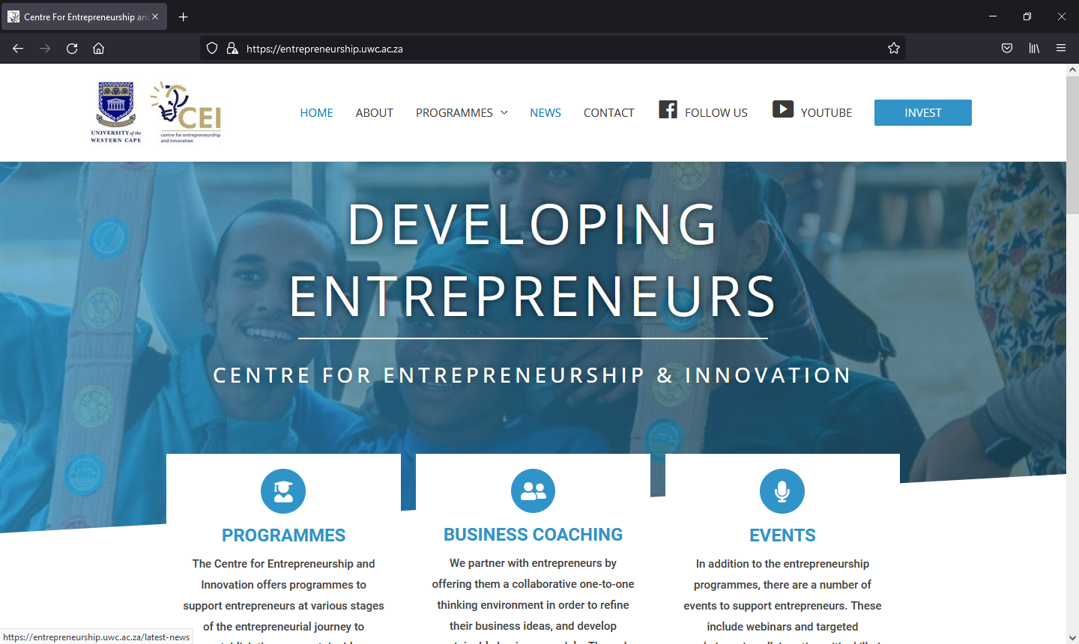
(https://entrepreneurship.uwc.ac.za/ )

Home:

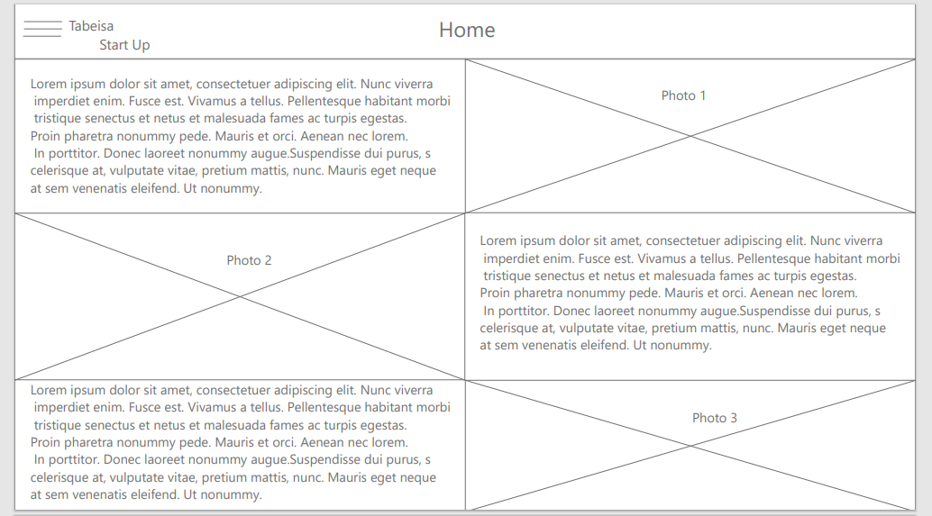

Navigation:

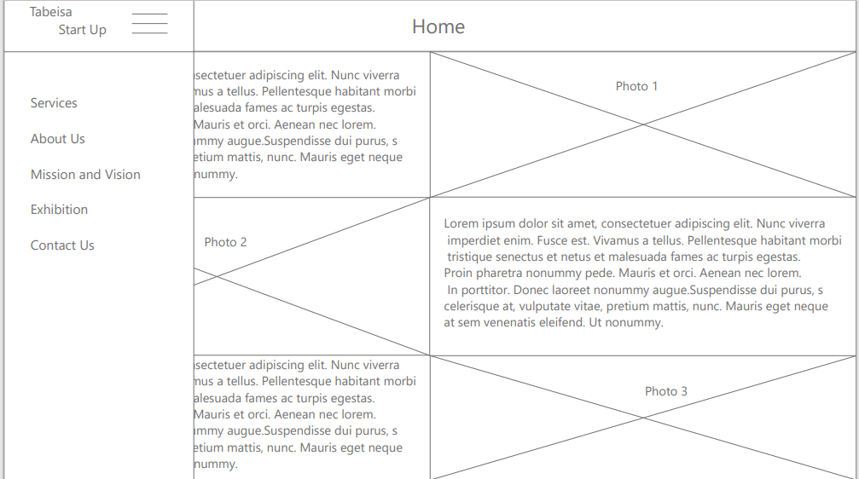

Mission and Vision:

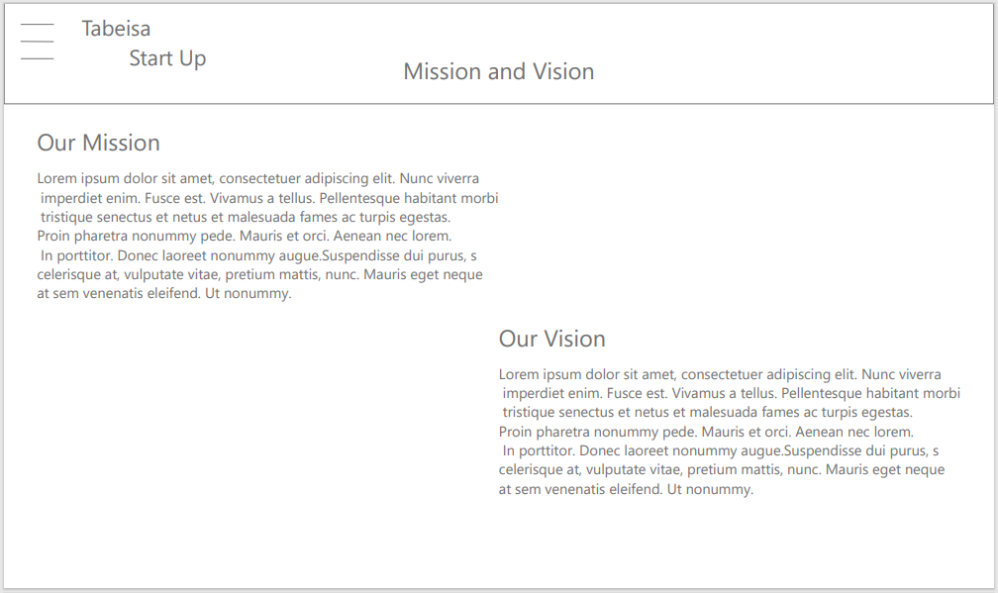

Services:

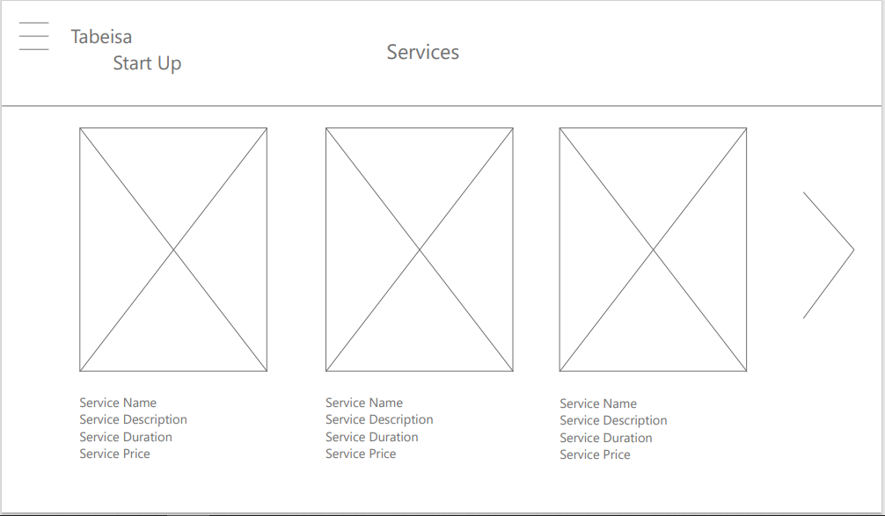

Design 1:

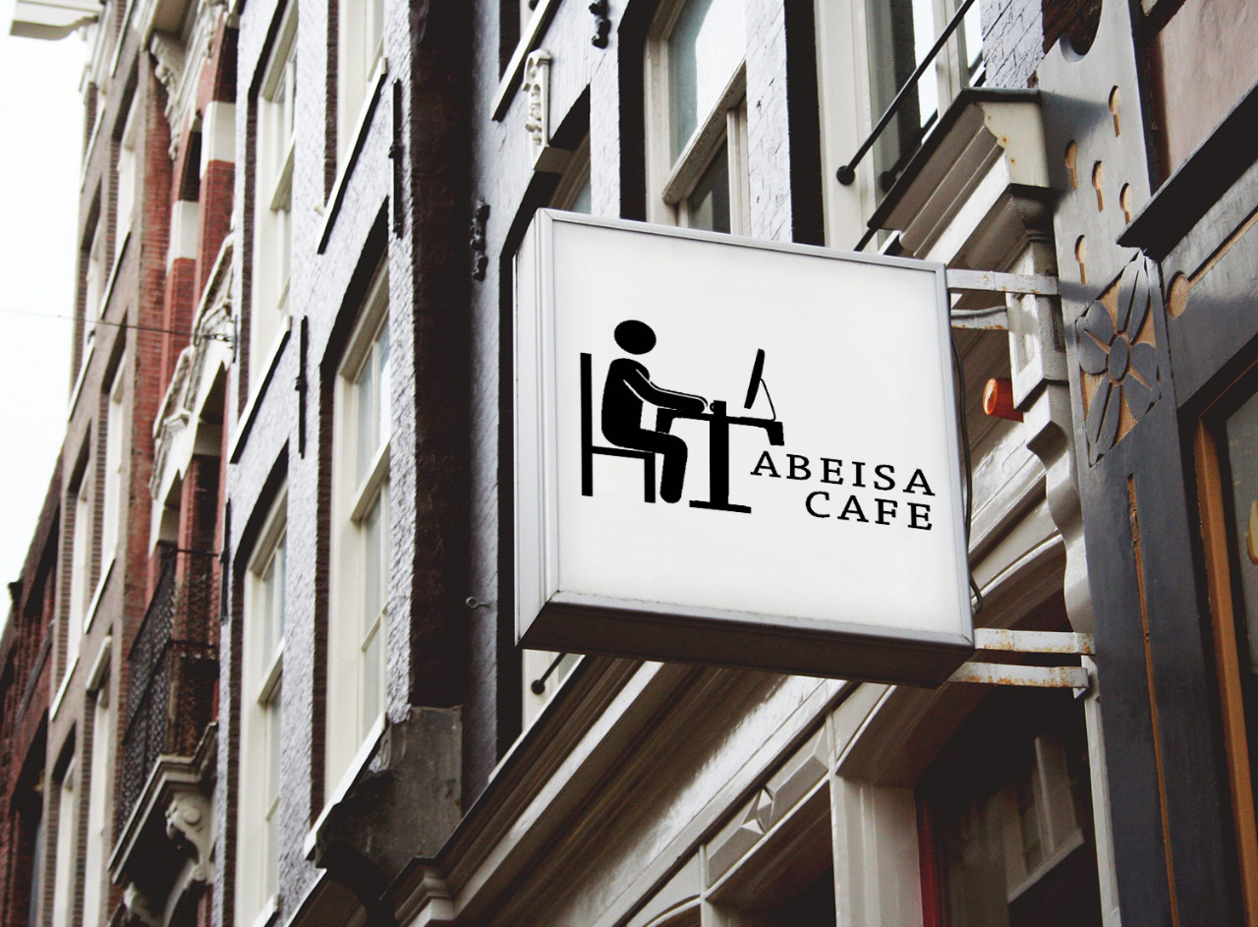

Design 2:
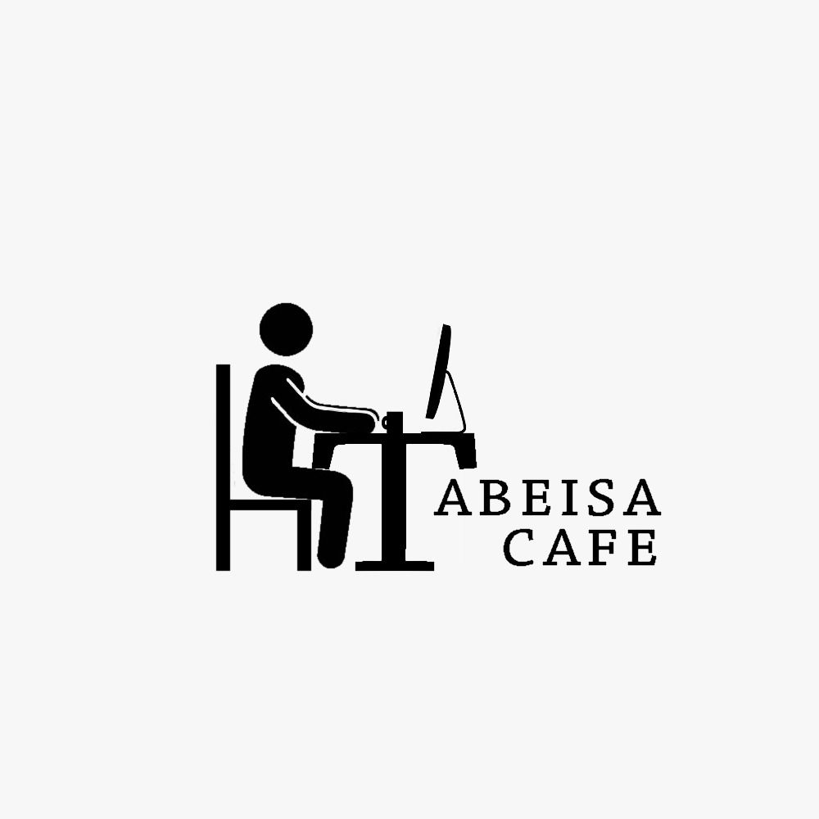

Design 3:
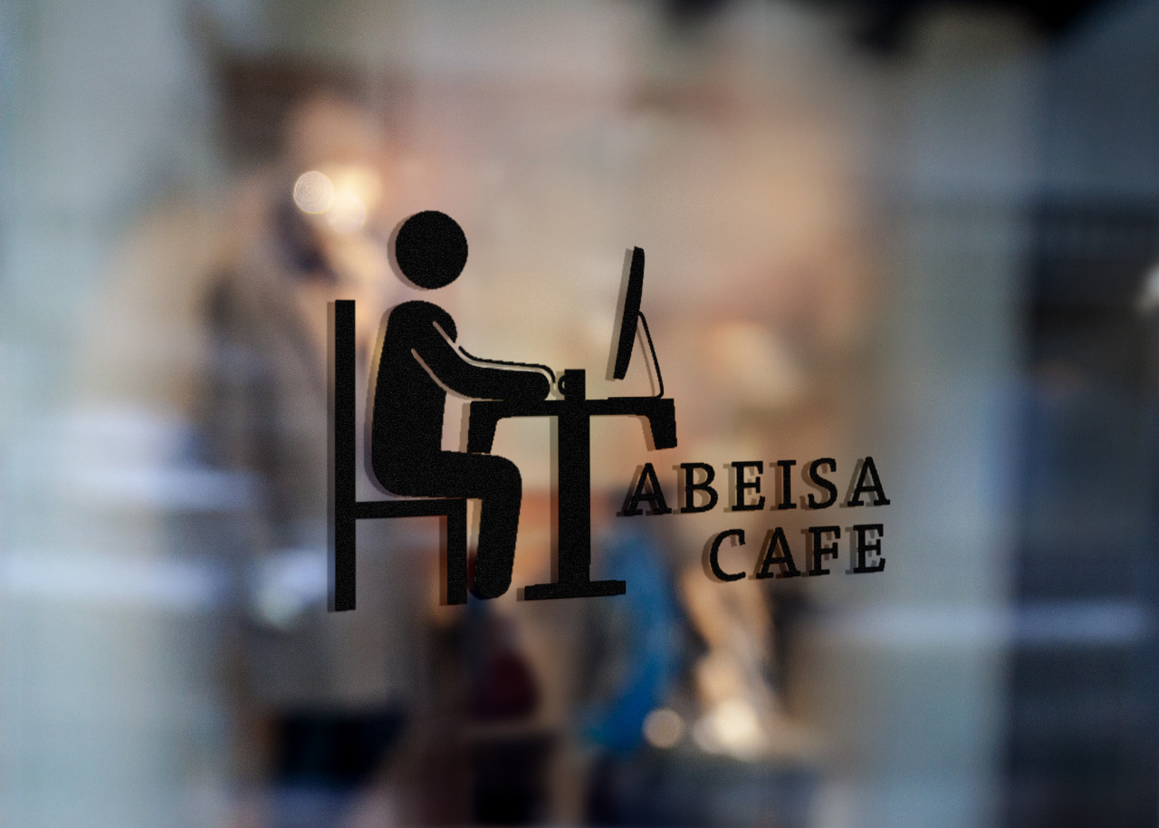

Hardware Interfaces
A hardware interface specifies the plugs, sockets, cables, and electrical signals that pass through each line between the CPU and a peripheral device or communications network.
With this system, we will need a network of computers to maintain the website and to ensure that security measures are put in place to provide security to the information on the company.

Software interfaces (programming interfaces) are the languages, codes, and messages that programs use to communicate with each other and to the hardware. The software that will be used to manage and maintain the website would be JavaScript, C++, and CSS coding application software, this will help create and maintain the websites for the organization.

Examples of the software that could be used are, Visual Studio, Visual studio code, IntelliJ, etc. These are all IDEs that are used to develop programs and websites, there are more variations of these types of IDEs but these specific IDEs are what we are familiar with.

Software Interfaces
The Tabiesa start-up will be running on the windows Operating system for the ease of support and user friendliness. The Tabiesa application will communicate with an SQL database to record and receive client information. For communication, Tabiesa will make use of telecommunication as well as MS teams, this will be for used for meetings and the distribution of documents.
The incoming and outgoing data that will be sent through-out the system will be client information which will be handled through the database, as well as documents and messages which will be sent through MS teams.
API’s sends and receives information from the server therefore before communication can be established, the client’s device needs to be connected to the internet. An API is needed as it provides services needed such as: User registration and login, database access, data modification, file access, storage as well as client-to-client messaging.
Global data areas (GDA) is a concept where a variable or function is declared globally allowing the data to be accessed by all other functions this of course greatly assists with creating an operating system capable of multitasking as all the data is fetched from one area. Using this method allows users to easily navigate the website created as there is no conflicts created through islands of information. Users can navigate multiple tabs of the website while at the same time still saving the information such as log in details to provide user specific content. While implementation constraints are responsible for controlling routing and placement, this job is then made easier as all necessary data is located in one area

Communications Interfaces
Communication is one of the most important aspects when it comes to designing a website as it is responsible for ensuring a clear message for visitors. Ensuring that your website gives visitors a positive user experience directly affects your longevity and relevancy in the industry. It is important to give users short but concise messages as well as an attractive site to keep them engaged. Encrypting the website by enabling HTTPS is very important for providing a secure search experience. This is needed for any personally identifiable information. HTTPS enables website encryption by running HTTP over the Transport Layer Security protocol.

When discussing data transfer rates you have to take the traffic your website is handling into consideration. For example if our website is getting 20000 visitors a month averaging at 5 pages per viewer we would need about 5GB of bandwidth per month, provided that the website has an average page size of 50KB.

When discussing synchronization in Java we are referring to the capability of controlling the access of threads to shared resources. Using the synchronized method by using the synchronization keywords are necessary for avoiding concurrency when using multiple threads.

System Features
<This template illustrates organizing the functional requirements for the product by system features, the major services provided by the product. You may prefer to organize this section by use case, mode of operation, user class, object class, functional hierarchy, or combinations of these, whatever makes the most logical sense for your product.>

Email:
4.1.1 Description and Priority
Email feature is used by the users to contact Tabeisa startup café with enquires and other questions they may have. This feature is a high priority, because the users need a way to contact the business.
4.1.2 Stimulus/Response Sequences
- User use Textbox to email address
- Enter message in comment box
- Hit the send button to send email
4.1.3 Functional Requirements
REQ-1: Send Email to Tabeisa Business account – A user enters email address and add a comment it sends email the Tabeisa’s business email.
REQ-2: Feedback Email – A user receive feedback in the form of an email.

FAQ Bot:
    - Description and Priority
FAQ (Frequently Asked Question) Bot is a feature that user can use to ask questions and the bot will answer with automated answers. This feature is a high priority, because it helps users not have to wait long periods of time for a response.
    - Stimulus/Response Sequences

- User Click the FAQ bot Icon
- Chat box opens
- User ask question
- Bot replies if it is question the bot unable to answer
- The user need to ask again
- User receive desired answer

    - Functional Requirements
REQ-1: Bot answer a user’s FAQ – A user enters question and the bot replies with answer

4.3 News Portal:
4.3.1 Description and Priority
Description:
This feature will provide the Tabeisa Start-Up Café with a platform to showcase and
exhibit various of their successful projects, current projects they are working on or projects they are involved with as well as projects they will be starting or getting involved with soon. This feature will also give Tabeisa the opportunity to attract sponsors and investors to get involved with some of their projects where they will gain the necessary support that they require. This platform will also allow the Tabeisa Start-Up Café to announce any important events that may be taking place or workshops that they may be hosting as an initiative to assist in aiding start-up businesses.

Priority: Medium
4.3.2 Stimulus/Response Sequences
- The user needs to visit the Tabeisa Start-Up Café website.
- The user then needs to navigate to the “News Portal” tab on the navigation bar.
- The user then needs to click on the “News Portal” tab as it will take the user to the “News Portal” page.
- The user will then see all the past, current ad up and coming projects of the institution.
- The user then needs to select a project that they wat to view as it will take the user to the respective page.
- The user will then see all the information and content that is available for the respective project.
- The user can once again navigate to the “Home” tab on the navigation bar.
- The user can then click on the “Home” tab which will take them back to the institutions landing page.

4.3.3 Functional Requirements
REQ 1: Share information about projects – A user can view information about various projects and decide to get involved with some of these projects and how to go about that.
REQ 2: Share content related to projects – A user can view media content related to all projects and their success.
REQ 3: Share news about events or workshops – A user can view all the details related to events or workshops that are taking place.

4.4 Business Portal:
4.4.1 Description and Priority
Description:
The feature will provide the Tabeisa Start-Up Café with a platform that will enable them
to assist start-up businesses with all the necessary services and processes to get them
businesses up and running successfully. This feature will allow Tabeisa Start-Up Café to
track and manage various business processes with ease to ensure their clients get the best
professional assistance that will enable them to turn their start-up businesses into
successful enterprises.

Priority: High

4.4.2 Stimulus/Response Sequences
- The user needs to visit the Tabeisa Start-Up Café website.
- The user then needs to navigate to the “Business Portal” tab on the navigation bar.
- The user then needs to click on the “Business Portal” tab as it will take the user to the “Business Portal” page.
- The user will then be prompt to login in order to use the portal.
- The user can use their login credentials by simply entering the username and password if they have already registered an account.
- The user that has not registered an account needs to do so before they can use the portal.
- When the user has successfully registered and account and has successfully login, they will be able to view all the services that are available.
- The user can navigate to the respective services they would like to make use of.
- When a user is done using the portal the user can navigate to the logout button and click on it to logout of the portal.
- The user can once again navigate to the “Home” tab on the navigation bar.
- The user can then click on the “Home” tab which will take them back to the institutions landing page.

4.4.3 Functional Requirements
REQ 1: Register users – A user fills out an online registration form where data is captured which enables them to login and use the system.
REQ 2: Register start-up businesses – A user can register their business by filling out an online form and attach supporting documentation to successfully register the business.
REQ 3: Provide support to start-up businesses – A user can request assistance to support them through processes an agent will be assigned to assist them to ensure all processes are successfully completed.

Other Nonfunctional Requirements

Performance Requirements
TABEISA start-up café performance requirements will merely be based on the system throughput and the run/response time functionality, meaning - How long does a user wait for a specific operation to happen and how quickly will the system respond to the users’ actions? We will also consider the capacity measures of lost, denied, or delay time due to possible network congestion, improper queuing, or configuration errors. Also, the latency which is time measured between the user’s device and the data centre to predict how long it takes for data to pass from one point of the users’ network to another This will help to understand how quickly the webpage will load for users.
Therefore, time recommendation should be:
- 0.1 – response or run time from when user prompts.
- 1 - 2 seconds - to scroll up and down the website at most.
- 3 second – when user will notice the delay, but without interrupted flow.
- 10 seconds – when user attention is completely lost caused by deny or delay of network.
In addition,
- Every successful or unsuccessful attempt by a user to access in the website system shall be recorded.
- A website should be capable enough to handle several users without affecting its performance.
- The software should be portable. So, moving from one OS to other OS does not create any problem.
- Privacy of information, the export of restricted technologies, intellectual property rights, etc. should be audited.

Safety Requirements
Tabeisa StartUp Café websites should ensure that no one can steal the website information or hack the website browser. It also ensures that only the server and the exchanging of information are the ones that can read and decipher the exchanged codes.
Information security is making sure that the website is available 24 hrs/day for your customers, it is ensuring only the correct people can administer the website's content, it is preventing unauthorised alteration or destruction of the website data, it is avoiding the website being used to distribute other people's software, it is ensuring that the employees cannot accidentally delete valuable information, it is stopping the website from being used to damage users' computers and it is protecting your reputation.
In order for the website to be safe enough they should
- monitoring usage of website closely
- providing users with a simple way to report phishing and other scams
- make sure you don't disclose your website users' personal information
- using HTTPS for all forms and sensitive data, avoiding pop-ups and using a simple consistent domain name
- putting your login form on a single separate page (not on every page or the home page)
- being careful of the format and content of your own emails to customers, suppliers, partners, etc
- define layouts and design in corporate identity definitions, policies and standards and adhere to these to help users identify variations

Security Requirements
Tabeisa StartUp Café websites should ensure that no one can steal the website information or hack the website browser. It also ensures that only the server and the exchanging of information are the ones that can read and decipher the exchanged codes.
Information security is making sure that the website is available 24 hrs/day for your customers, it is ensuring only the correct people can administer the website's content, it is preventing unauthorized alteration or destruction of the website data, it is avoiding the website being used to distribute other people's software, it is ensuring that the employees cannot accidentally delete valuable information, it is stopping the website from being used to damage users' computers and it is protecting your reputation.
For the website to be safe enough they should

- monitoring usage of website closely
- providing users with a simple way to report phishing and other scams
- make sure you don't disclose your website users' personal information
- using HTTPS for all forms and sensitive data, avoiding pop-ups, and using a simple consistent domain name
- putting your login form on a single separate page (not on every page or the home page)
- being careful of the format and content of your own emails to customers, suppliers, partners, etc.
- define layouts and design in corporate identity definitions, policies and standards and adhere to these to help users identify variations

Software Quality Attributes
Adaptability
The software should be able to be changed and adapt to new business requirements, patches and software updates.

Availability
The software should always be up and running. Even if the is a fault and it is taken down, it should be fully operational as soon as possible. The system should reliable and dependable so whatever task it has to do has to be able to be doable and perform whatever task is required.

Correctness
The software should function correctly in terms of how all functions work like clicking buttons, doing calculation and getting output from your input. The software should be functional where it should be.

Maintainability
It should be easy to modify and update the existing code of the software. The errors and defects of the system should be easy to locate and fix. The maintenance of the system shouldn’t be costly and complicated.

Reliability
The software should always be up and running under any condition. Using the software should also be consistent every time even if it is used on different devices such as pcs and mobile devices.

Reusability
The code and modules of the software should be cost effective and be reusable in the future and in other applications that accepts them.

Security
Unauthorized access should be prevented from the software. The information of the system should be safe and not be stolen or get lost. The software should not be vulnerable to viruses and there should be protection against any unauthorized access. Security checks should happen regularly.

Testability
The code of the system should be easily tested. Defects and errors should be easily located. The software should be able to be divided in entities and tested individually.

Usability
The software should have a user intuitive user interface. It should be user friendly and easy to learn for new users. The navigation should be complicated, and everything should be clear with how icons and names are defined.

Business Rules
- A user will register on the Tabeisa start up café website.
- An existing user will log in on the Tabeisa start up café website using their credentials.
- Registered users will receive training required to manage a project.
- Training is provided at the Tabeisa start up café by their many partners.
- Trainers will have one or more users to give appropriate training.
- Registered users will be aided with registering their companies, applying for finance, tendering patent registering etc.

